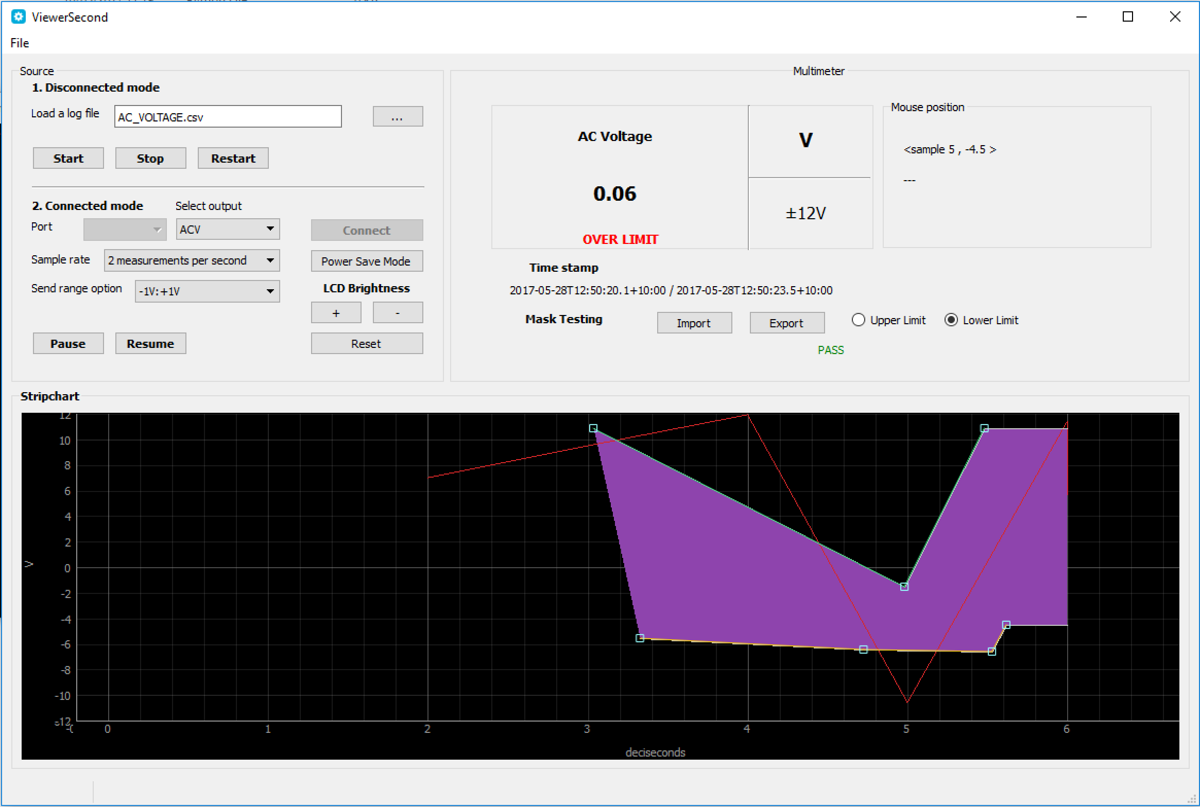

This application is divided into four main sections:

1. Source -> Disconnected mode:
   * Gives the user control over loading a log file, start plotting a log file, stop and pause plotting the log file.
2. Source -> Connected mode:
   * Gives the user the control over serial communication with the device. It mimics the possible controls on the device such as changing mode, changing range and resetting the plot.
3. Multimeter:
   * To show all the possible information about the readings and other useful information provided by the app.
4. Stripchart:
   * To show the data acquired either via serial communication or via a log file, and enables the user to implement mask testing system by choosing the type of the limit, then clicking anywhere on the plot.